ZVA MMEM:DEL:CORR Case-Sensitivity Bug

# Intent

For testing purposes, I need to be able to programmatically upload, add and remove cal groups. Specifically, I found this bug while testing a dialog for choosing a calibration from a list of channel calibrations and cal groups. This dialog needs to be able to handle various situations. One of those situations is when there are calibrated channels but no cal groups. To achieve this, I programmatically delete all cal groups. Doing so uncovered this bug.

# Problem

The MMEMory:DELete:CORRection command does not handle case-insensitive input correctly. For example, when deleting a cal group with the name “Cal Group 1” by referring to it as “cal group 1” the firmware will remove the corresponding “Cal Group 1.cal” file, but fail to remove the cal group reference from the list of available cal groups. This discrepancy can cause the firmware to crash in certain situations (which I unfortunately uncovered).

This is a problem because the command used to query available cal groups, MMEMory:CATalog?, returns lower-cased filenames. Cal groups with capital letters are therefore incorrectly handled programmatically.

More specifically, I need a function that queries the list of cal groups and then deletes them all via MMEM:CAT? and MMEM:DEL:CORR. At this point the bug is uncovered. Later on in the testing process that cal group is replaced and used. This causes the firmware to crash.

# Scope

Confirmed on:  
- ZVA firmware 3.60 in simuation mode  
- ZVA firmware 3.70 on ZVA40 4-Port instrument

This command works correctly on the ZNB firmware 2.70.

# Work-around

Using the more general MMEMory:DELete command to delete the cal files directly seems to prevent the firmware from crashing. It does not, however, get the firmware to display the correct list of cal groups to a manual user. If the user were to try to apply a cal group that has been deleted it would inexplicably not work (no warning or error is given).

# Example

**In this example we will start the firmware with a particular cal group “Cal Group 1”, then attempt to delete it using its lower-cased filename. This will uncover the bug. We will then try to replace and use “Cal Group 1”. This will cause the firmware to crash.**

**# With the firmware closed, copy the cal group file  
# (“Cal Group 1.cal”) to the following folder on the ZVA:  
# C:\Rohde&Schwarz\Nwa\Calibration\Data**

**# Open the firmware**

**# Preset the instrument:  
*RST**

**# Confirm that cal group “Cal Group 1” is present:  
# Cal (hard key) -> Cal Manager (soft key)**

**# Delete the cal group programmatically using a  
# lower-cased cal group reference  
MMEM:DEL:CORR ‘cal group 1.cal’**

**# Navigate back to the Cal Manager  
# [Cal (hard key) -> Cal Manager (soft key)]  
# and confirm that the cal group is still present in the menu.  
# Also, navigate to  
# C:\Rohde&Schwarz\Nwa\Calibration\Data  
# and confirm that the cal group has indeed been removed.  
# Listing a removed cal group in the Cal Manager menu is a bug.**

**# To make the firmware crash:**

**# Manually copy the cal group back to the ZVA  
# folder C:\Rohde&Schwarz\Nwa\Calibration\Data  
# This can of course be done programmatically, but for simplicity  
# we will do this manually.**

**# Load the cal group into channel 1  
# (case-sensitivity is not important here)  
MMEM:LOAD:CORR 1, ’Cal Group 1.cal’**

**# This should cause the following SCPI command error:**

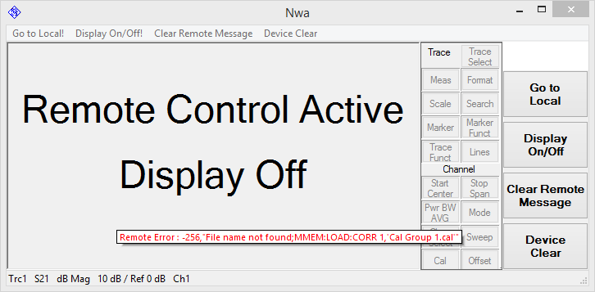 **Figure 1***SCPI command error #1*

**# Navigate back to the Cal Manager. “Cal Group 1” should still be  
# present, but it will not be applied to channel 1.**

**# Now try to delete the cal group with lower-case filenames as if  
# you are continuing to do so programmatically  
MMEM:DEL:CORR ‘cal group 1.cal’**

**# This should cause another SCPI command error:**

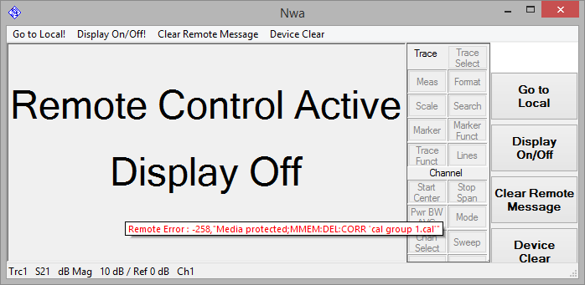 **Figure 2***SCPI command error #2*

**At this point the firmware is unstable. The easiest way to cause it to crash is to close it.**

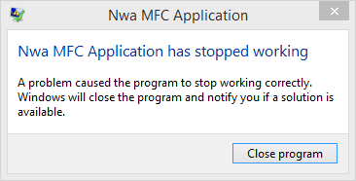 **Figure 3***Firmware is unstable and will crash*